Circuit Theory
MATLAB Assignment - 2
SAMBHAV R JAIN 107108103
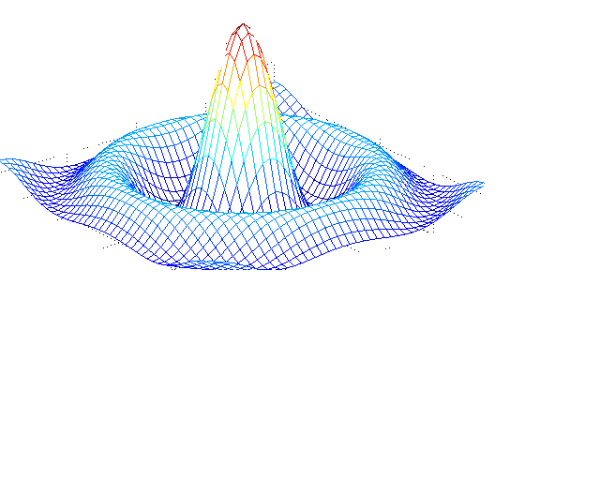

Question 1

CIRCUIT DIAGRAM:

PROGRAM CODE:

clear all;
close all;
clc;
disp('Enter the value of maximum voltage(Vm):');
Vm=input('');
disp('Enter the phase angle(deg) of V:');
th1=input('');
disp('Enter the value of maximum current(Im):');
Im=input('');
disp('Enter the phase angle(deg) of I:');
th2=input('');
% th1--theta1
% th2--theta2
% ph--phase angle
% pf--power factor
ph=(th2-th1)*pi/180;
pf=cos(ph);
disp('The power factor is:');
disp(pf);
Pavg=(Vm*Im*pf/2);
disp('The average power is:');
disp(Pavg);
Vrms=Vm/sqrt(2);
disp('The rms value of voltage is:');
disp(Vrms);

OUTPUT:
Enter the value of maximum voltage(Vm):
5
Enter the phase angle(deg) of V:
30
Enter the value of maximum current(Im):
6
Enter the phase angle(deg) of I:
60
The power factor is:
0.8660

The average power is:
12.9904

The rms value of voltage is:
3.5355

Question 2
CIRCUIT DIAGRAM:
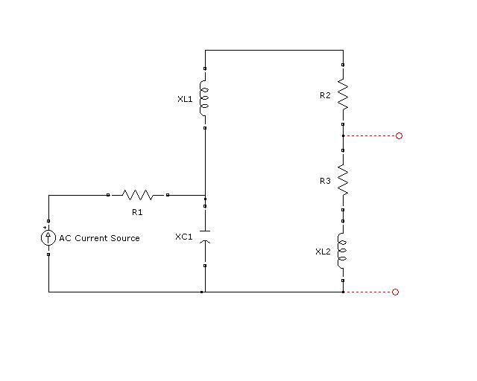

- To calculate Thevenin Resistance Rth:
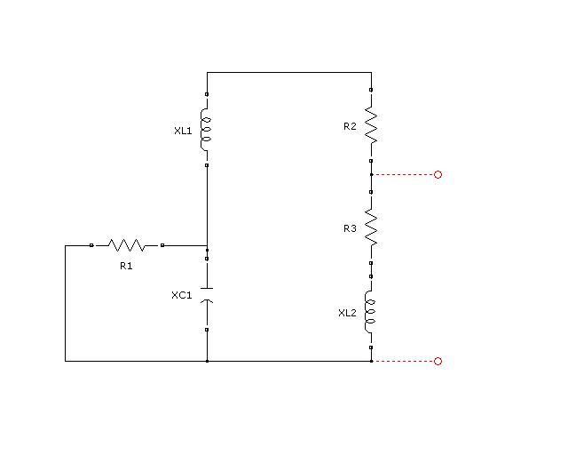

- To calculate Norton Current In :
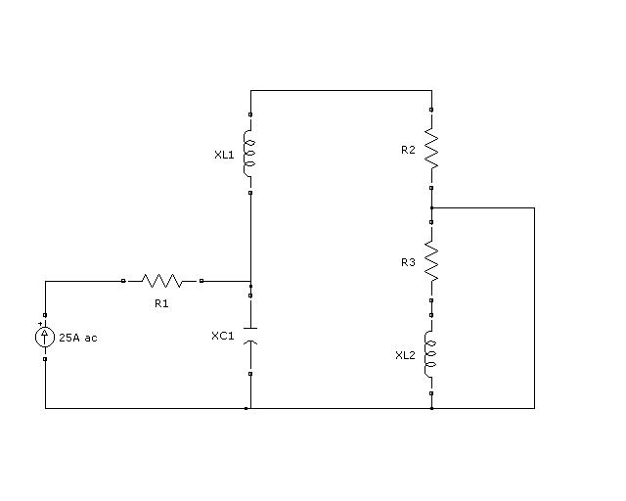

PROGRAM CODE:
clear all;
close all;
clc;
disp('Enter the value of current source:');
I=input('');
disp('Please enter the value of R1:');
R1=input('');
disp('Please enter the value of R2:');
R2=input('');
disp('Please enter the value of R3:');
R3=input('');
disp('Please enter the value of XL1:');
XL1=input('');
disp('Please enter the value of XL2:');
XL2=input('');
disp('Please enter the value of XC1:');
XC1=input('');
Zth=(R2+j*(XL1-XC1))*(R3+j*XL2)/(R2+R3+j*(XL1+XL2-XC1));
disp('The Thevenin impedance is calculated as:');
disp(Zth);
Isc=(i*(XC1*I))/(-R2+i*(XC1-XL1));
disp('The short circuit current is calculated as:');
disp(Isc);
Vth=Isc*Zth;
disp('The Thevenin voltage is calculated as:');
disp(Vth);
disp('The Norton equivalent current source is:');
disp(Isc);
disp('The value of Z(load) for maximum power transfer is:');
disp(conj(Zth));

OUTPUT:
Enter the value of current source:
25
Please enter the value of R1:
5
Please enter the value of R2:
4
Please enter the value of R3:
5
Please enter the value of XL1:
3
Please enter the value of XL2:
5
Please enter the value of XC1:
3
The Thevenin impedance is calculated as:
2.6415 + 0.7547i

The short circuit current is calculated as:
0 -18.7500i

The Thevenin voltage is calculated as:
14.1509 -49.5283i

The Norton equivalent current source is:
0 -18.7500i

The value of Z(load) for maximum power transfer is:
2.6415 - 0.7547i

Question 3

CIRCUIT DIAGRAM:

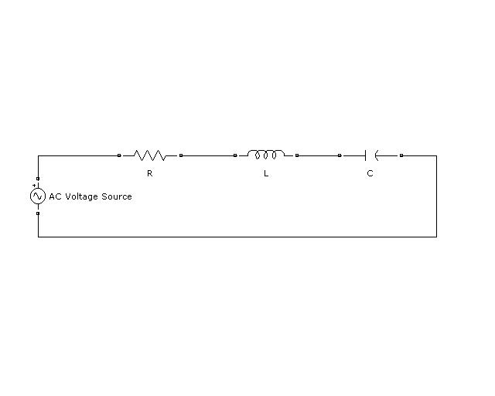

PROGRAM CODE:
clear all;
close all;
clc;
disp('Please enter the value of AC voltage source:');
V=input('');
disp('Please enter the value of resistance R:');
R=input('');
disp('Please enter the value of inductance L:');
L=input('');
disp('Please enter the value of capacitance C:');
C=input('');
fr=1/(2*pi*sqrt(L*C));
disp('The resonant frequency(in hertz) for the given circuit is:');
disp(fr);
BW=R/(2*pi*L);
disp('The band width BW of the series RLC circuit is:');
disp(BW);
Q=fr/BW;
disp('The Q factor of the series RLC circuit is:');
disp(Q);
syms f
subplot(3,3,1);
fplot(@(f) V*R/sqrt(R^2+(L*2*pi*f-1/(C*2*pi*f))^2),[fr-50 fr+50]);
xlabel('Frequency(Hz)-------->');
ylabel('Voltage across resistor(V)--------->');
title('Vr v\s f');
subplot(3,3,2);
fplot(@(f) V/sqrt(R^2+(L*2*pi*f-1/(C*2*pi*f))^2),[fr-50 fr+50]);
xlabel('Frequency(Hz)-------->');
ylabel('Current(A)--------->');
title('I v\s f');
subplot(3,3,3);
fplot(@(f) sqrt(R^2+(L*2*pi*f-1/(C*2*pi*f))^2),[fr-50 fr+50]);
xlabel('Frequency(Hz)-------->');
ylabel('Impedance(ohm)--------->');
title('Z v\s f');
subplot(3,3,4);
fplot(@(f) L*2*pi*f,[0 fr+50]);
xlabel('Frequency(Hz)-------->');
ylabel('Inductive Reactance(ohm)--------->');
title('XL v\s f');
subplot(3,3,5);
fplot(@(f) 1/(C*2*pi*f),[0 fr+50]);
xlabel('Frequency(Hz)-------->');
ylabel('Capacitive Reactance(ohm)--------->');
title('XC v\s f');
subplot(3,3,6);
fplot(@(f) V*(1/(C*2*pi*f))/sqrt(R^2+(L*2*pi*f-1/(C*2*pi*f))^2),[fr-50 fr+50]);
xlabel('Frequency(Hz)-------->');
ylabel('Voltage across capacitor(V)--------->');
title('Vc v\s f');
subplot(3,3,7);
fplot(@(f) V*(L*2*pi*f)/sqrt(R^2+(L*2*pi*f-1/(C*2*pi*f))^2),[fr-50 fr+50]);
xlabel('Frequency(Hz)-------->');
ylabel('Voltage across inductor(V)--------->');
title('Vl v\s f');

OUTPUT:

Please enter the value of AC voltage source:
230
Please enter the value of resistance R:
10
Please enter the value of inductance L:
.1
Please enter the value of capacitance C:
10e-6
The resonant frequency(in hertz) for the given circuit is:
159.1549

The band width BW of the series RLC circuit is:
15.9155

The Q factor of the series RLC circuit is:
10.0000

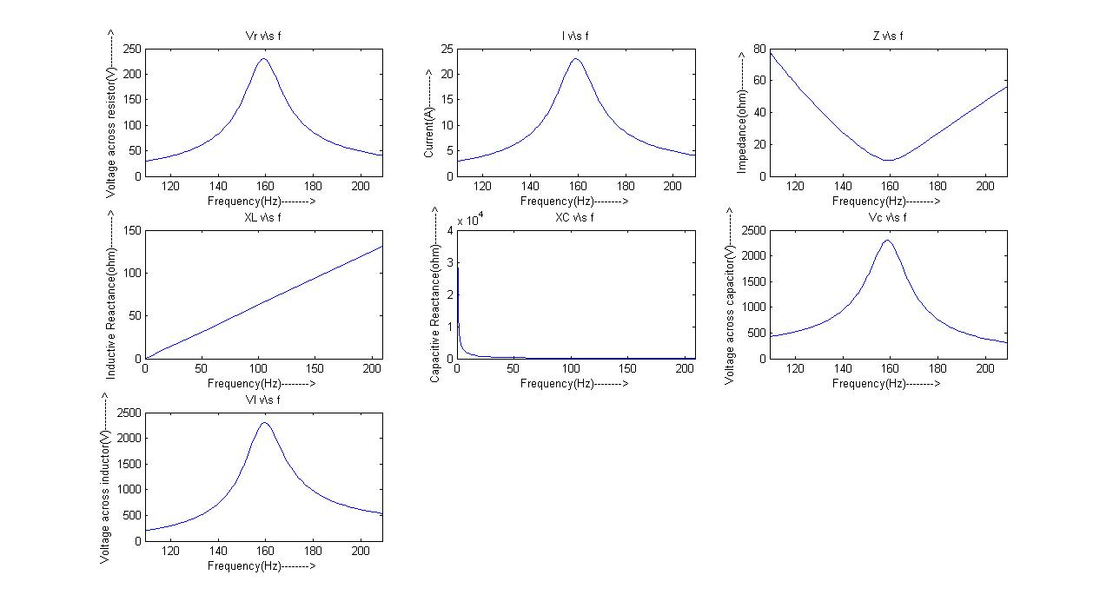
GRAPHS

Question 4

CIRCUIT DIAGRAM:
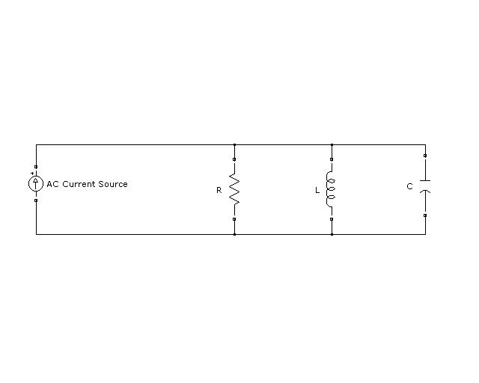

PROGRAM CODE:

clear all;
close all;
clc;
disp('Please enter the value of resistance R:');
R=input('');
disp('Please enter the value of inductance L:');
L=input('');
disp('Please enter the value of capacitance C:');
C=input('');
fr=1/(2*pi*sqrt(L*C));
disp('The resonant frequency(in hertz) for the given circuit is:');
disp(fr);
disp('The resonant frequency(in rad/s) for the given circuit is:');
disp(2*pi*fr);
BW=1/(2*pi*R*C);
disp('The band width BW of the parallel RLC circuit is:');
disp(BW);
Q=fr/BW;
disp('The Q factor of the parallel RLC circuit is:');
disp(Q);
f1=fr-(BW/2);
f2=fr+(BW/2);
disp('The lower and upper cut-off frequencies for the given parallel RLC circuit are:');
disp(f1);
disp(f2);
% To calculate impedance of the circuit
disp('Please enter the maximum value of AC current source:');
I=input('');
Irms=I/sqrt(2);
disp('Please enter the frequency in rad/s:');
w=input('');
Z=1/sqrt((1/R)^2+(C*w-1/(L*w))^2);
Vrms=Irms*Z;
disp('The voltage(rms) appearing across the parallel elements are:');
disp(Vrms);
syms f;
subplot(3,2,1);
fplot(@(f) 1/sqrt((1/R)^2+(2*pi*f*C-1/(2*pi*f*L))^2),[fr-50 fr+100]);
xlabel('Frequency(Hz)-------->');
ylabel('Impedance(ohm)--------->');
title('Z v\s f');
subplot(3,2,2);
% Vm=Im*Z
fplot(@(f) 10/sqrt((1/R)^2+(2*pi*f*C-1/(2*pi*f*L))^2),[fr-50 fr+100]);
xlabel('Frequency(Hz)-------->');
ylabel('Max voltage(V)--------->');
title('Vm v\s f');
subplot(3,2,3);
% Vrms=Irms*Z
fplot(@(f) (10/sqrt(2))/sqrt((1/R)^2+(2*pi*f*C-1/(2*pi*f*L))^2),[fr-50 fr+100]);
xlabel('Frequency(Hz)-------->');
ylabel('Rms voltage(V)--------->');
title('Vrms v\s f');
subplot(3,2,4);
fplot(@(f) (10/sqrt((1/R)^2+(2*pi*f*C-1/(2*pi*f*L))^2))/R,[fr-50 fr+100]);
xlabel('Frequency(Hz)-------->');
ylabel('Max current in resistor(A)--------->');
title('Ir v\s f');
subplot(3,2,5);
fplot(@(f) (10/sqrt((1/R)^2+(2*pi*f*C-1/(2*pi*f*L))^2))/(L*2*pi*f),[fr-50 fr+100]);
xlabel('Frequency(Hz)-------->');
ylabel('Max current in inductor(A)-------->');
title('Il v\s f');
subplot(3,2,6);
fplot(@(f) (10/sqrt((1/R)^2+(2*pi*f*C-1/(2*pi*f*L))^2))*(C*2*pi*f),[fr-50 fr+100]);
xlabel('Frequency(Hz)-------->');
ylabel('Max current in capacitor(A)-------->');
title('Ic v\s f');

OUTPUT:

Please enter the value of resistance R:
12
Please enter the value of inductance L:
2
Please enter the value of capacitance C:
3e-6
The resonant frequency(in hertz) for the given circuit is:
64.9747

The resonant frequency(in rad/s) for the given circuit is:
408.2483

The band width BW of the parallel RLC circuit is:
4.4210e+003

The Q factor of the parallel RLC circuit is:
0.0147

The lower and upper cut-off frequencies for the given parallel RLC circuit are:
-2.1455e+003

2.2755e+003

Please enter the maximum value of AC current source:
10
Please enter the frequency in rad/s:
1800
The voltage(rms) appearing across the parallel elements are:
84.6930

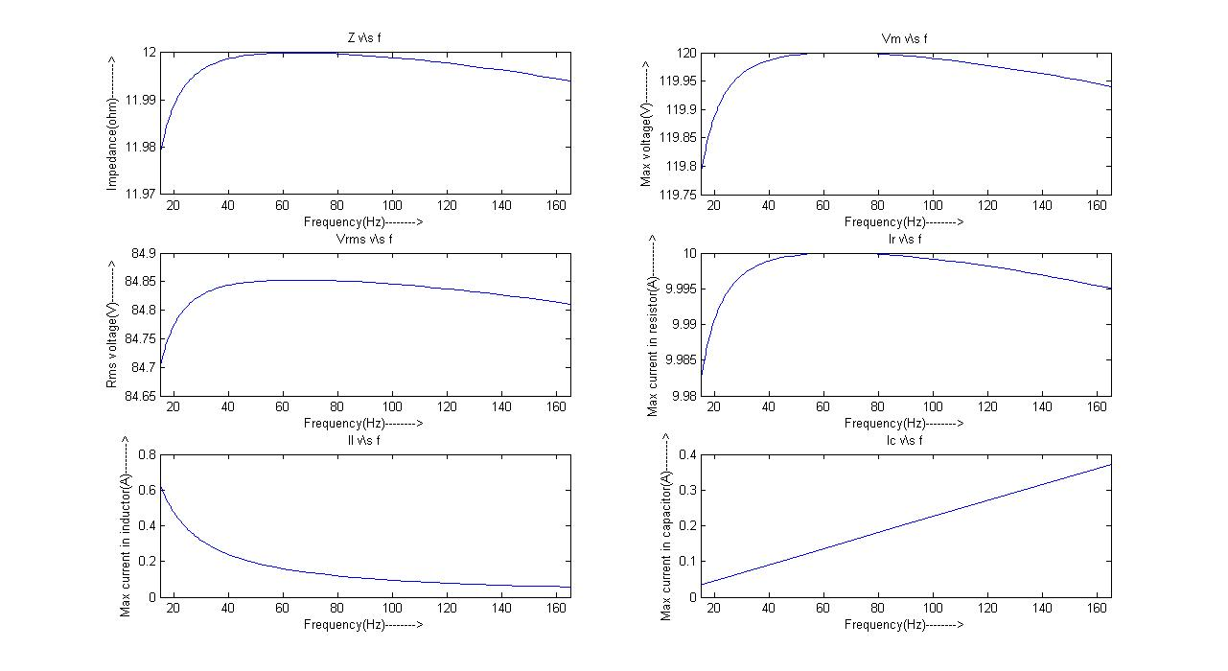
GRAPH:

Question 5(a)

CIRCUIT DIAGRAM:

PROGRAM CODE:

% Balanced Y-Y positive system
clear all;
close all;
clc;
disp('Please enter the value of phase voltage(reference):');
Van=input('');
Vbn=(Van*cos(deg2rad(-120))+i*Van*sin(deg2rad(-120)));
Vcn=(Van*cos(deg2rad(-240))+i*Van*sin(deg2rad(-240)));
disp('Plase enter the transmission line impedance:');
Zt=input('');
disp('Please enter the load impedance:');
Zl=input('');
Z=[(Zt+Zl) (-Zt-Zl) 0;0 (Zt+Zl) (-Zt-Zl);1 1 1];
V=[(Van-Vbn);(Vbn-Vcn);0];
I=inv(Z)*V;
disp('The respective line currents are:');
disp(I);
pf=real(Zt+Zl)/sqrt((real(Zt+Zl))^2+(imag(Zt+Zl))^2);
disp('The power factor of the load is:');
disp(pf);
P=sqrt(3)*Van*(sqrt((real(I(1)))^2+(imag(I(1)))^2))*pf;
disp('The total power(in Watts) supplied to the load is:');
disp(P);

OUTPUT:
Please enter the value of phase voltage(reference):
120
Plase enter the transmission line impedance:
1+0.5i

Please enter the load impedance:
11+4.5i
The respective line currents are:
8.5207 - 3.5503i
-7.3350 - 5.6040i
-1.1857 + 9.1543i
The power factor of the load is:
0.9231

The total power(in Watts) supplied to the load is:
1.7710e+003

Question 5(b)
CIRCUIT DIAGRAM:

PROGRAM CODE:
% Un-balanced Y-delta positive system
clear all;
close all;
clc;
disp('Please enter the value of phase voltage(ref----phase angle=0):');
Van=input('');
Vbn=(Van*cos(deg2rad(-120))+i*Van*sin(deg2rad(-120)));
Vcn=(Van*cos(deg2rad(-240))+i*Van*sin(deg2rad(-240)));
disp('Please enter Raa1:');
Raa1=input('');
disp('Please enter Rbb1:');
Rbb1=input('');
disp('Please enter Rcc1:');
Rcc1=input('');
disp('Please enter Zab:');
Zab=input('');
disp('Please enter Zbc:');
Zbc=input('');
disp('Please enter Zca:');
Zca=input('');
Z=[(Raa1+Rbb1+Zab) -Rbb1 -Zab;Zab Zbc -(Zab+Zbc+Zca);-Rbb1 (Rbb1+Rcc1+Zbc) -Zbc];
V=[Van-Vbn;0;Vbn-Vcn];
I=inv(Z)*V;
disp('The respective loop currents are:');
disp(I);
disp('Thus the respective line currents are:');
disp(I(1));
disp(I(2)-I(1));
disp(-I(2));

OUTPUT:
Please enter the value of phase voltage(ref----phase angle=0):
120
Please enter Raa1:
1
Please enter Rbb1:
2
Please enter Rcc1:
1
Please enter Zab:
10+5i
Please enter Zbc:
15+7i
Please enter Zca:
12-3i
The respective loop currents are:
26.0597 - 2.2870i
9.8895 -13.9614i
13.0172 - 4.0519i
Thus the respective line currents are:
26.0597 - 2.2870i

-16.1702 -11.6744i

-9.8895 +13.9614i

